# **GLC-Class**

Mercedes-Benz GLC-Class air suspension systems will provide an excellent and comfortable ride experience for the first 3-5 years after the vehicle leaves the factory. Slowly over time many of the rubber components will start deteriorating. This slow degradation of the rubber components such as Air Springs or Air Struts Rubber Bladders will cause small sometimes barely visible cracks or pinholes that will cause air in the system to slowly escape. When there is an air leak in your Mercedes-Benz GLC-Class air suspension system, it can cause the air suspension compressor or other electrical components to over work and burn out. When Mercedes-Benz GLC-Class air struts or air spring bags go out, your Mercedes-Benz GLC-Class is nearly impossible to drive. BAVARIA CENTER provides many solutions for your air suspension repair at a fraction of Dealership prices. We offer many Aftermarket Parts, New or Remanufactured, including Air Struts, Air Spring Bags, Compressors, Air Supply Solenoid Valve Blocks and more. Our friendly staff is available to assist you and your satisfaction is our guarantee! You may contact us for any questions or recommendations. We are here to help your Mercedes-Benz GLC-Class get back on the road!

# **GLC (C253) Coupe 2015+**

# **Mercedes AMG GLC 43 Air spring air suspension front A2133202100**

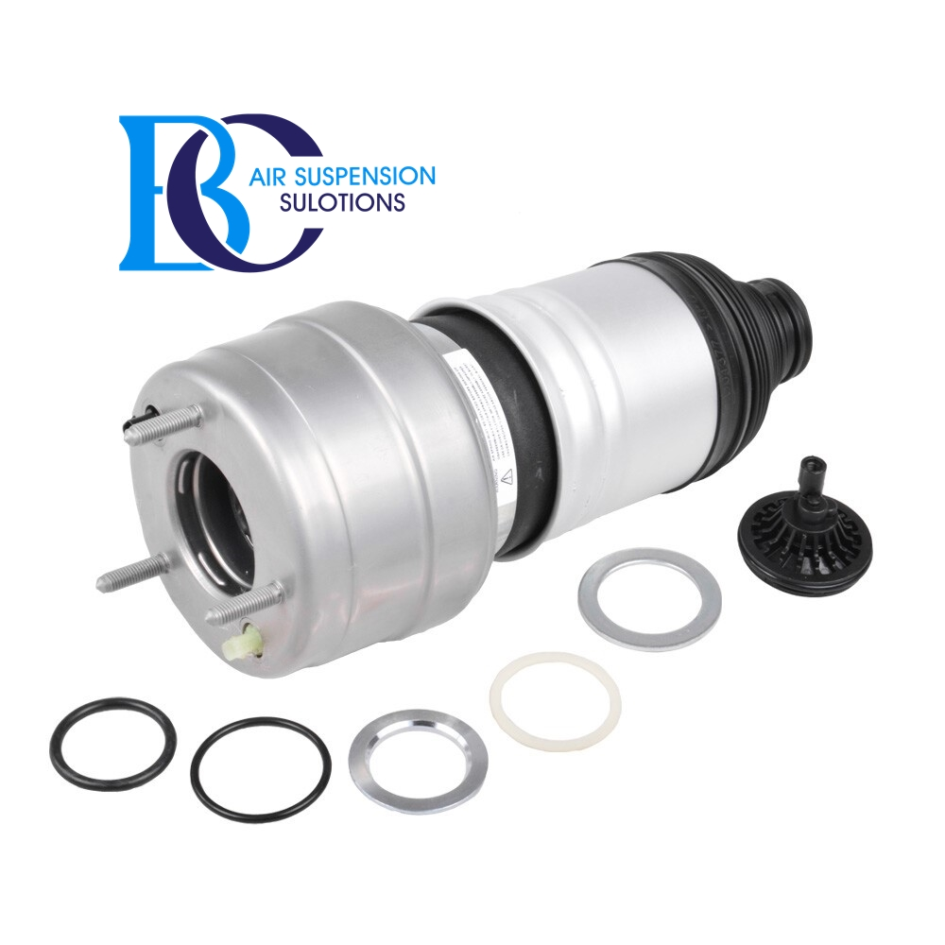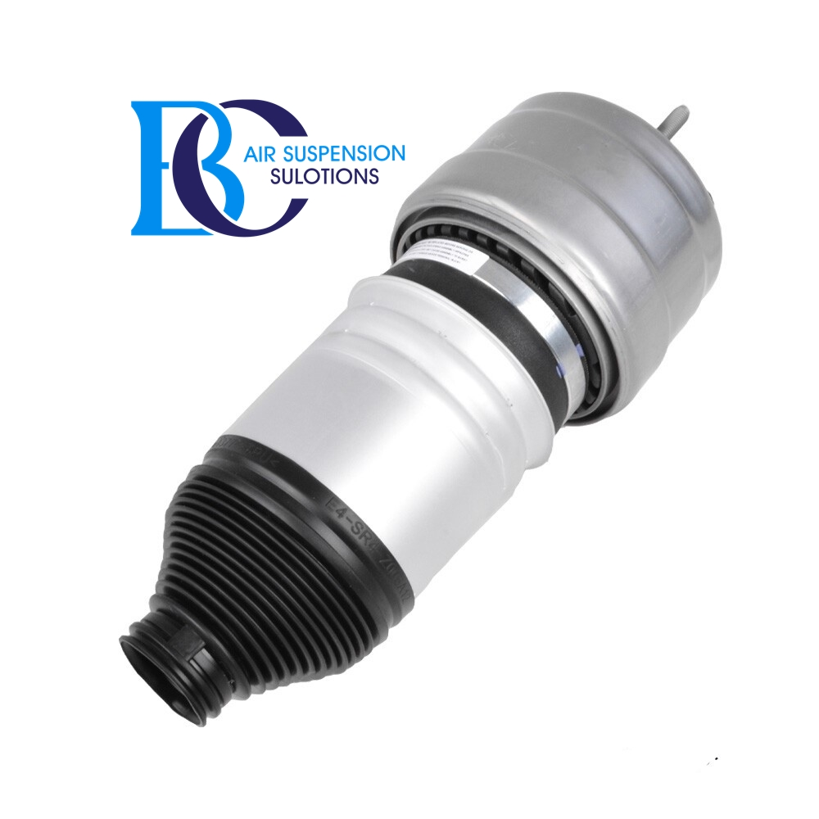

Description

This is the repair kit (air spring part) for the front shock absorber of the air suspension of the Mercedes AMG GLC 43 (253).

Repairing the strut makes sense only if the shock absorber still has a sufficient efficiency.

This repair kit should not be used when the shock absorber is oil leak.

If the air strut is in bad condition, but the shock absorber still has the best properties, you can use this set to restore the function of the complete shock absorber.

**It can be installed in the following vehicles:**

Mercedes GLC Coupe (C253) AMG 43 4-matic (253.364) 2016--

Mercedes GLC (X253) AMG 43 4-matic (253.964) 2016--

**Suitable air spring for shock absorbing strut with the following OEM part numbers:**

A2533206901, A2533200501, A2533207900, 2533206901, 2533200501, 2533207900

A2533207001, A2533200401, A2533208000, 2533207001, 2533200401, 2533208000

Matching air spring: A2533206300, A2533200400, A2133202100, 2533206300, 2533200400, 2133202100

Matching shock absorber: A2533203500, A2533203600, 2533203500, 2533203600

# **Mercedes GLC X253 Shock absorbing strut air suspension front left**

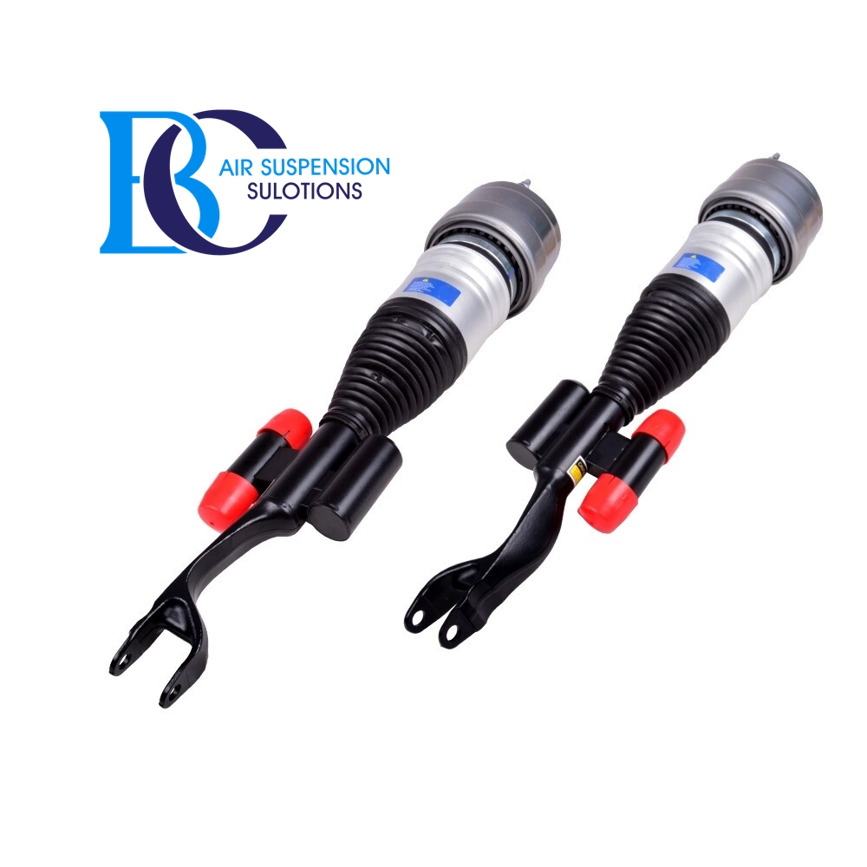

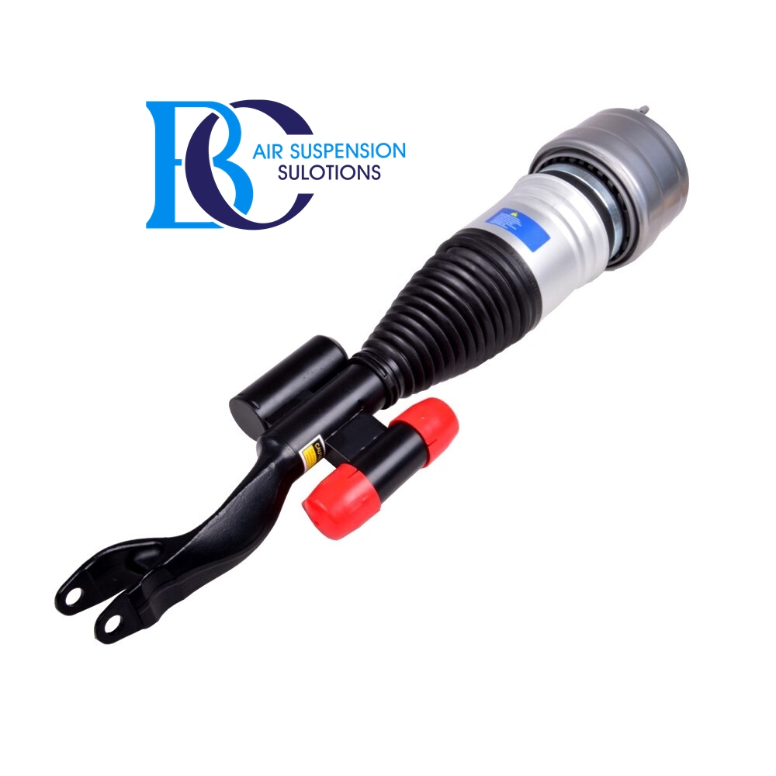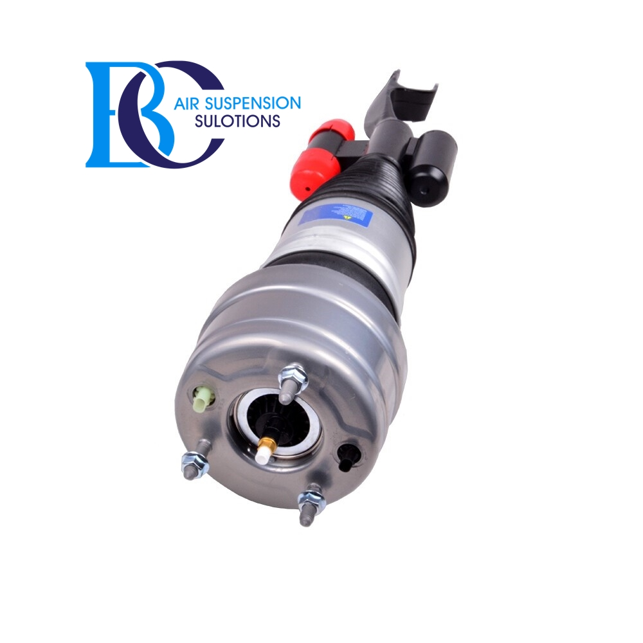

Description

This is the front left Airmatic air suspension strut on the Mercedes GLC X253.

**Can be installed in the following vehicles:**

Mercedes GLC X253 (2015--)

200 (253.942) 06.2016-04.2019

200 4-matic (253.943) 11.2015-04.2019

200 d (253.913) 04.2019--

200 d 4-matic (253.916) 04.2019--

200 EQ Boost (253.980) 04.2019--

200 EQ Boost 4-matic (253.981) 04.2019--

220 d (253.914) 04.2019--

220 d 4-matic (253.905, 253.903) 06.2015-04.2019

220 d 4-matic (253.915) 04.2019--

250 d 4-matic (253.909) 06.2015-04.2019

260 4-matic (253.946) 11.2015--

300 (253.948) 01.2016-04.2019

300 4-matic (253.949) 07.2015-04.2019

300 4-matic (253.949) 11.2015--

300 d 4-matic (253.919) 04.2019--

300 de 4-matic (253.911) 05.2020--

300 e 4-matic (253.953) 11.2019--

300 EQ Boost (253.983) 09.2020--

300 EQ Boost 4-matic (253.984) 04.2019--

350 d 4-matic (253.925) 10.2016-04.2019

350 e 4-matic (253.954) 01.2016-04.2019

400 d 4-matic (253.923) 08.2019--

F-CELL 4-matic (253.992, 253.993) 04.2020--

**OEM number:**

A2533200338, 2533200338

Matching air spring: A2133202100

Matching shock absorber: A2533207200

# **Mercedes GLC Coupe (C253) Shock absorbing strut air suspension front right**

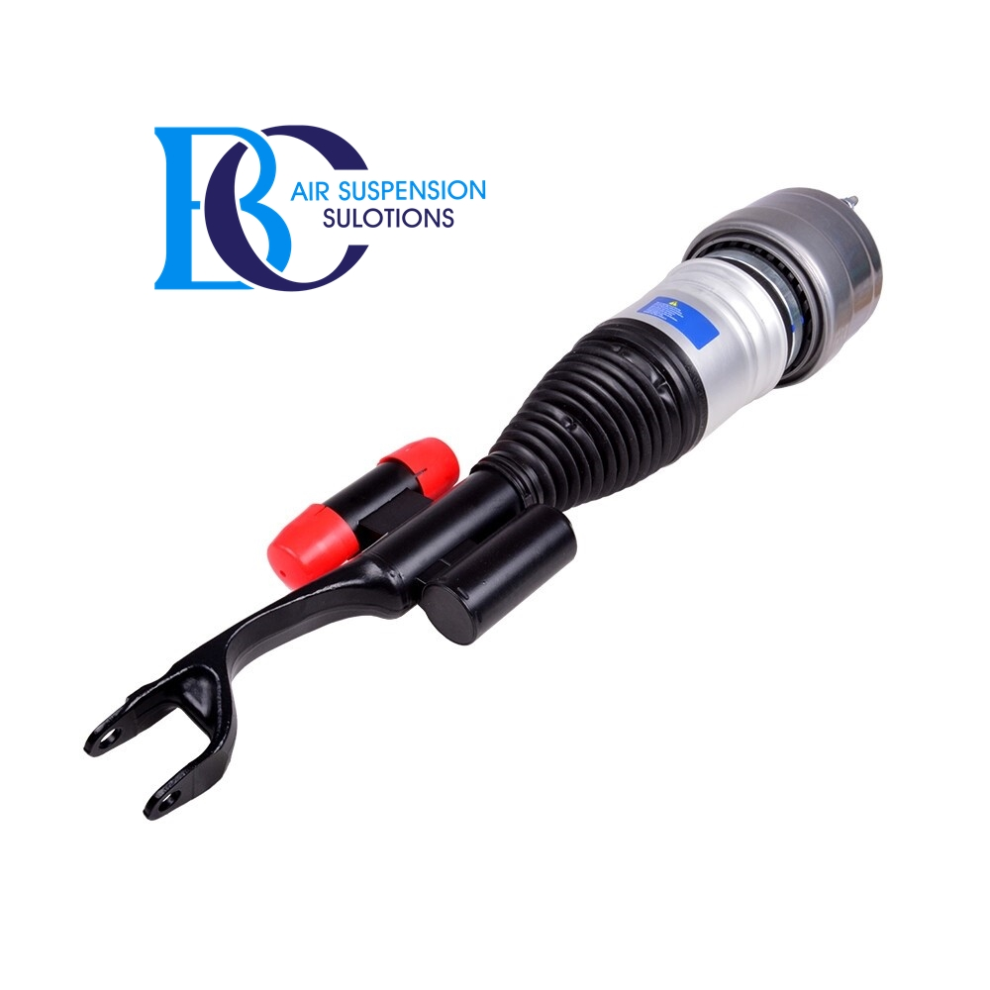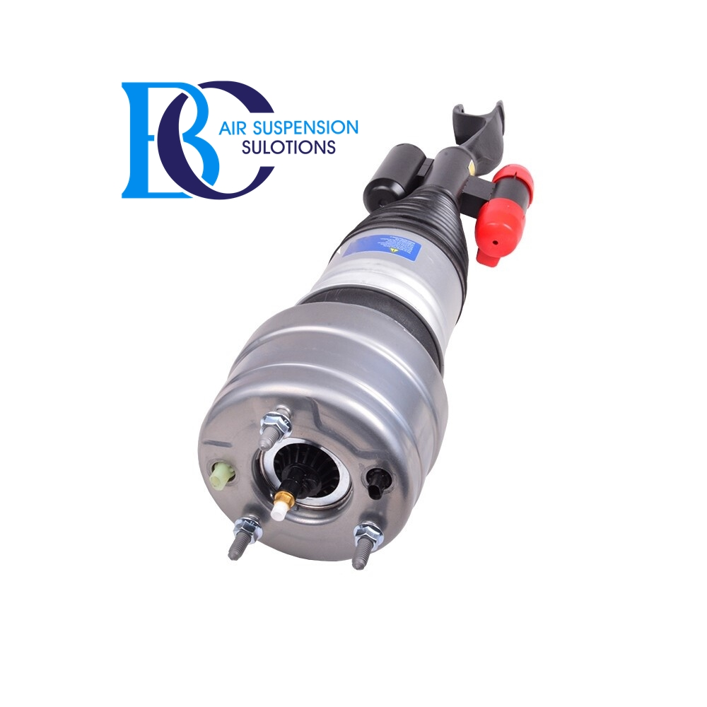

Description

This is the front right Airmatic air suspension strut on the Mercedes GLC Coupe (C253).

**Can be installed in the following vehicles:**

Mercedes GLC Coupe C253 (2016--)

200 (253.342) 06.2016-04.2019

200 4-matic (253.343) 11.2016-04.2019

200 d (253.313) 04.2019--

200 d 4-matic (253.316) 04.2019--

200 EQ Boost (253.380) 04.2019--

200 EQ Boost 4-matic (253.381) 04.2019--

220 d 4-matic (253.303, 253.305) 06.2016-04.2019

220 d 4-matic (253.315) 04.2019--

250 4-matic (253.346) 06.2016-04.2019

250 d 4-matic (253.309) 06.2016-04.2019

260 4-matic (253.381) 11.2019--

300 (253.383) 01.2019--

300 4-matic (253.349, 253.384) 10.2016-11.2019

300 d 4-matic (253.319) 04.2019--

300 de 4-matic (253.311) 05.2020--

300 e 4-matic (253.353) 11.2019--

300 EQ Boost 4-matic (253.384) 04.2019--

350 d 4-matic (253.325) 10.2016-04.2019

350 e 4-matic (253.354) 10.2016-04.2019

400 d 4-matic (253.323) 08.2019--

**OEM part number:**

A2533200438, 2533200438

Matching air spring: A2133202100

Matching shock absorber: A2533207300

# **Mercedes GLC 253 AMG Air spring AIRMATIC air suspension (Rear Left)**

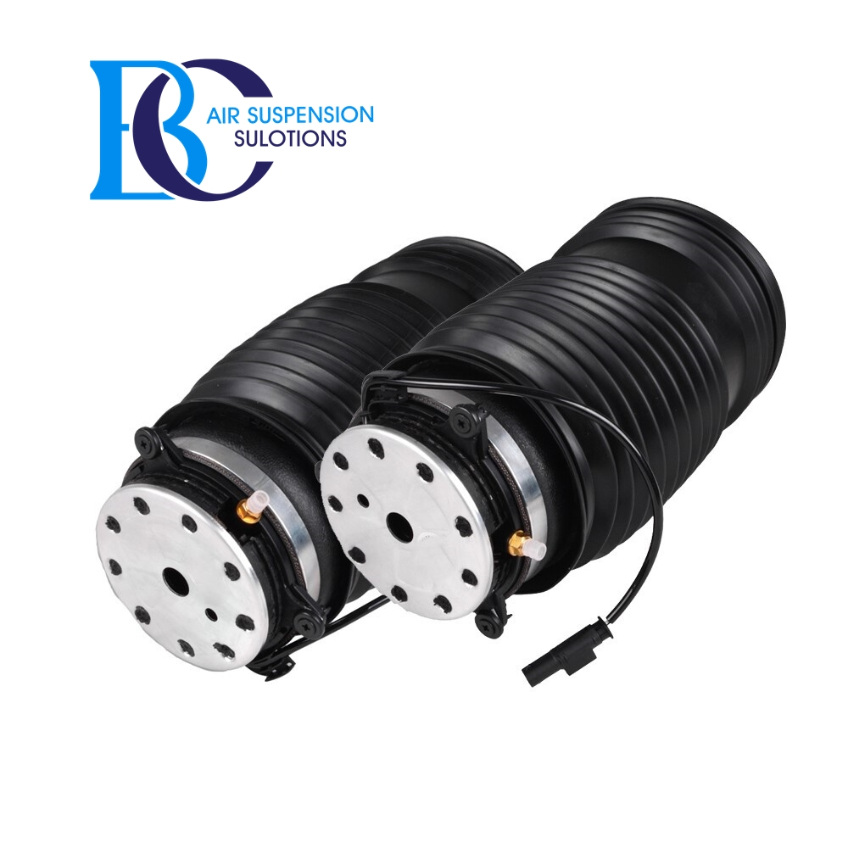

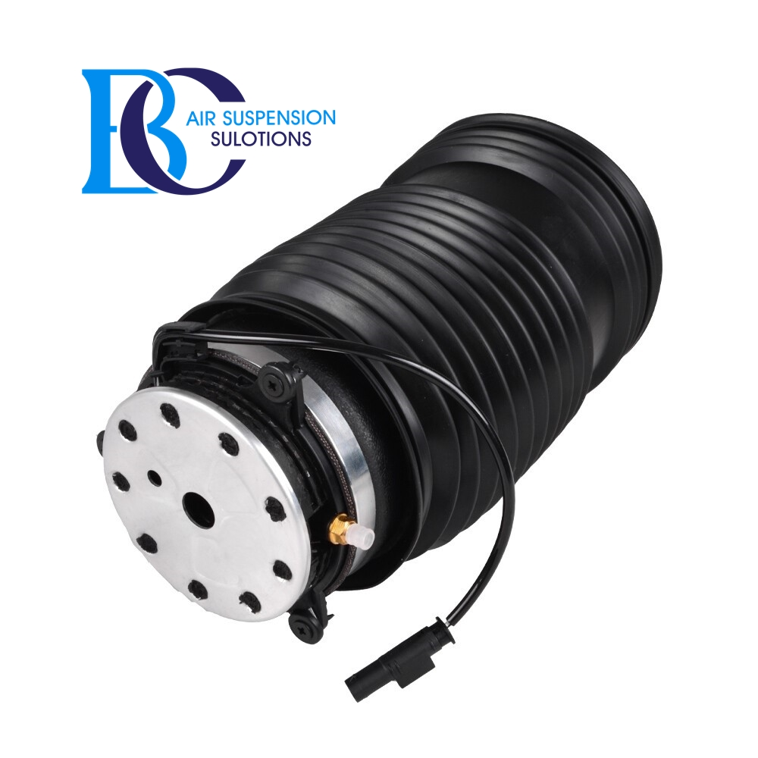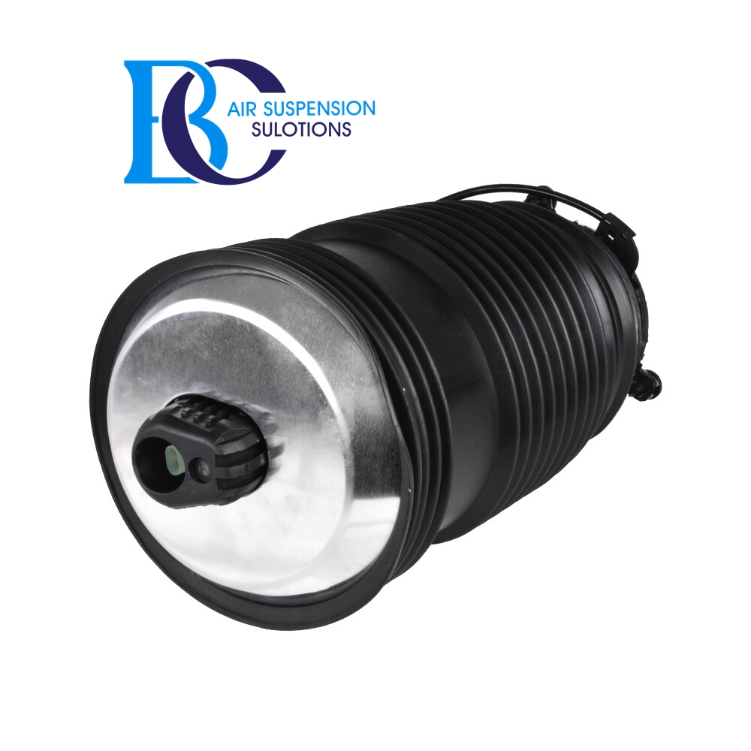

Description

This air spring A2133280100 for your Mercedes GLC Coupe AMG (C253) rear left for Mercedes Benz.  
   
 **Can be installed in the following vehicles:** Mercedes-Benz GLC Coupe AMG (C253) 2016--  
 AMG 43 4-matic (253.364) 10.2016--  
 AMG 63 4-matic+ (253.388) 06.2017--  
 AMG 63 S 4-matic+ (253.389) 06.2017--

AIRMATIC Dual Control / semi-active air suspension

**OEM part number:**

A2133280100, 2133280100

# **Mercedes GLC 253 AMG Air spring AIRMATIC air suspension (Rear Right)**

Description

This air spring A2133280200 for your Mercedes-Benz GLC Coupe AMG (C253) rear right for Mercedes Benz.  
   
 **Can be installed in the following vehicles:** Mercedes-Benz GLC Coupe AMG (C253) 2016--  
 AMG 43 4-matic (253.364) 10.2016--  
 AMG 63 4-matic+ (253.388) 06.2017--  
 AMG 63 S 4-matic+ (253.389) 06.2017--

AIRMATIC Dual Control / semi-active air suspension

**OEM number:**

A2133280200, 2133280200

# **Mercedes GLC (253) Compressor air suspension A0993200004**

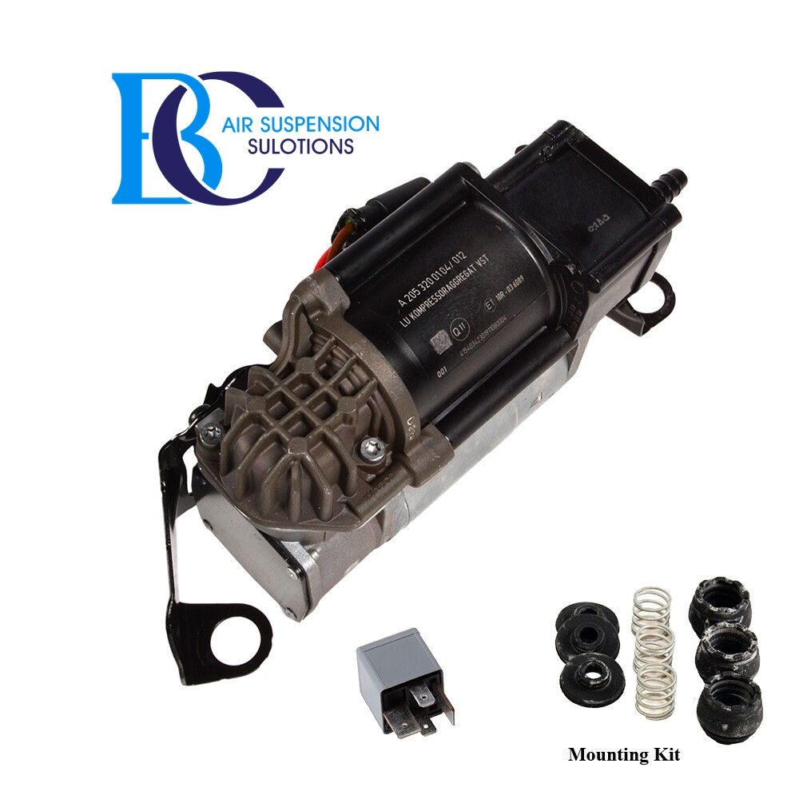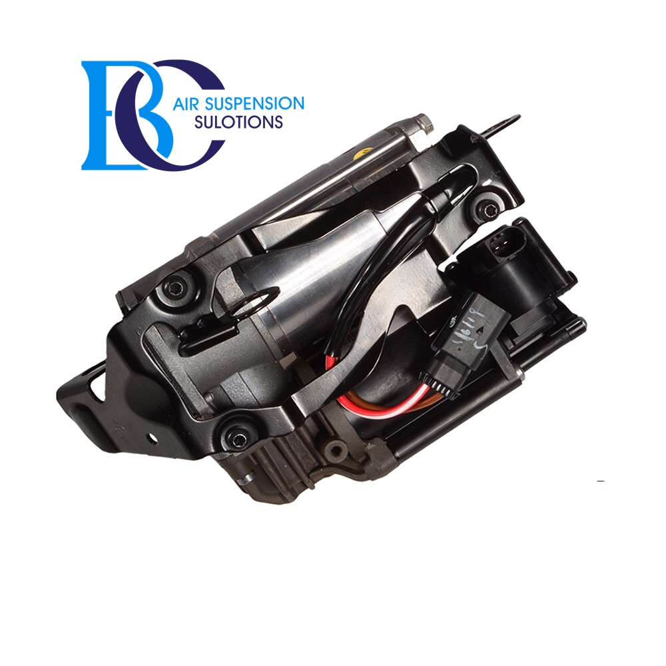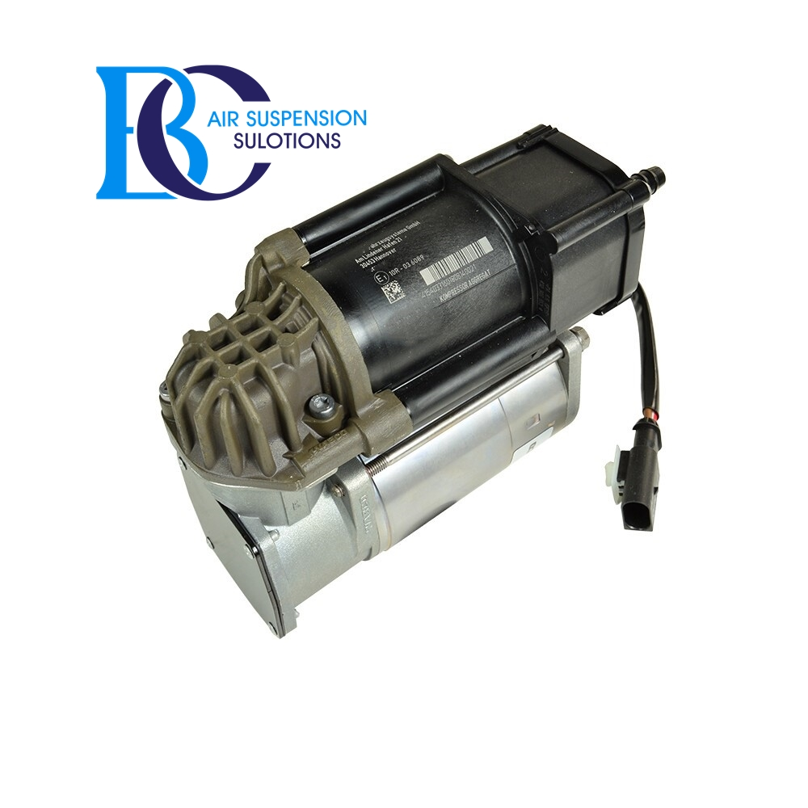

Description

This is the Mercedes air compressor A0993200004 for the Mercedes GLC (253).

**Can be installed in the following vehicles:**   
 Mercedes-Benz GLC-Class C253 Coupe 2015--  
 Mercedes-Benz GLC-Class X253 SUV Kombi 2015--   
  
 **OEM number of the air supply system:** 0993200004 , A0993200004 , 099320000480 , A099320000480  
 A2133209900, A2133204701, A2133202904, A2133202804, A2133004320, A2053200104  
 2133209900, 2133204701, 2133202904, 2133202804, 2133004320, 2053200104  
 4154030422, 415 403 042 2

# **Mercedes GLC 253 Valve air suspension A0993200258 AIRMATIC**

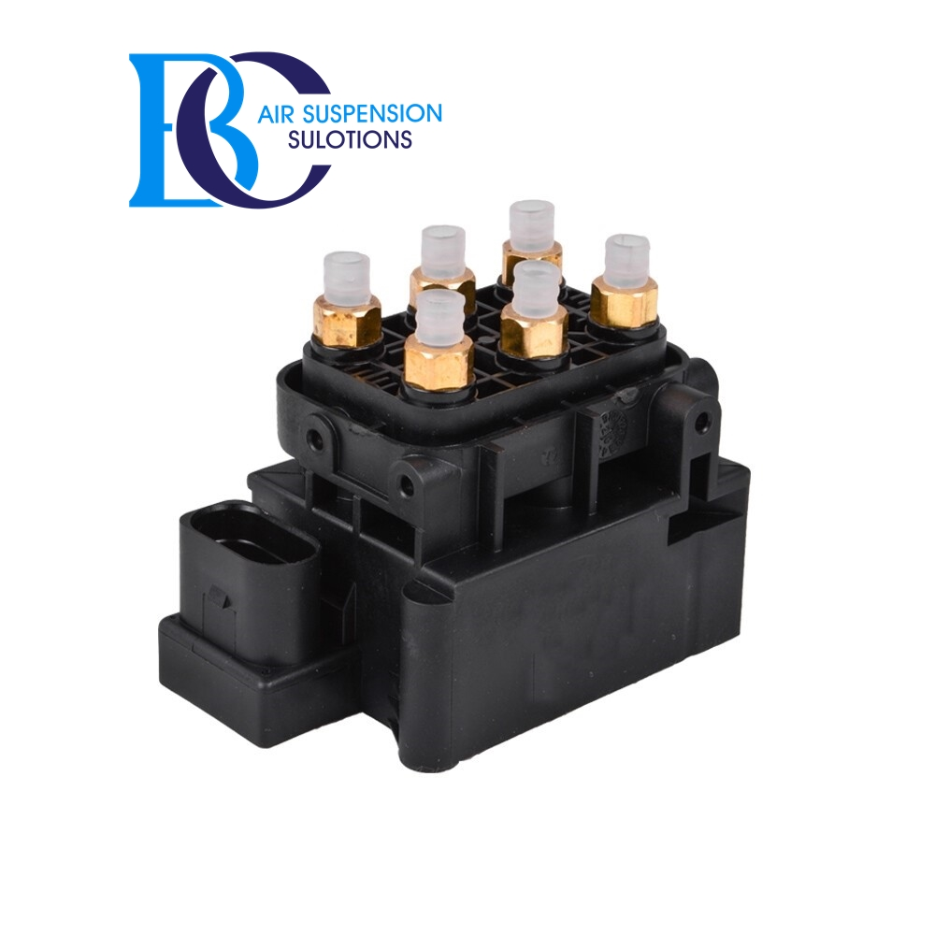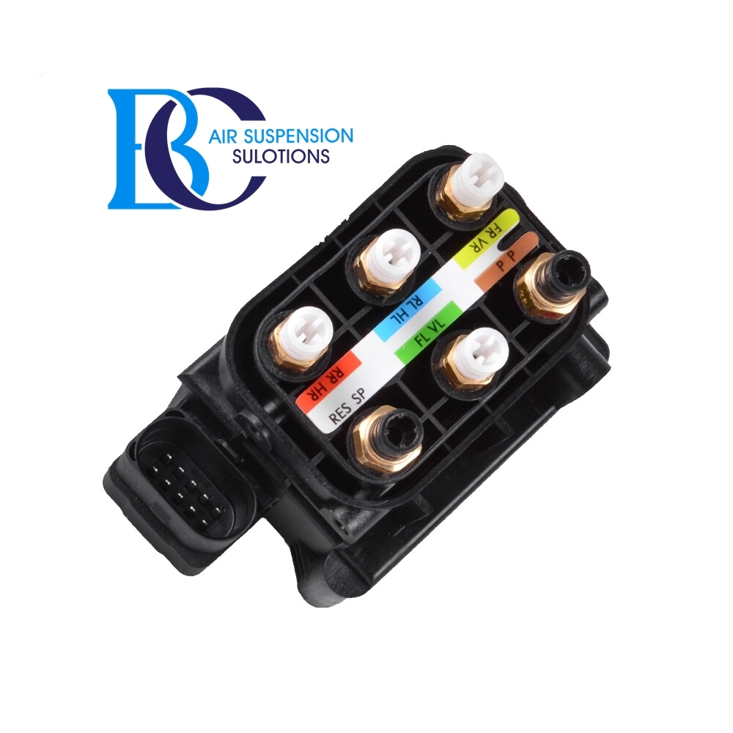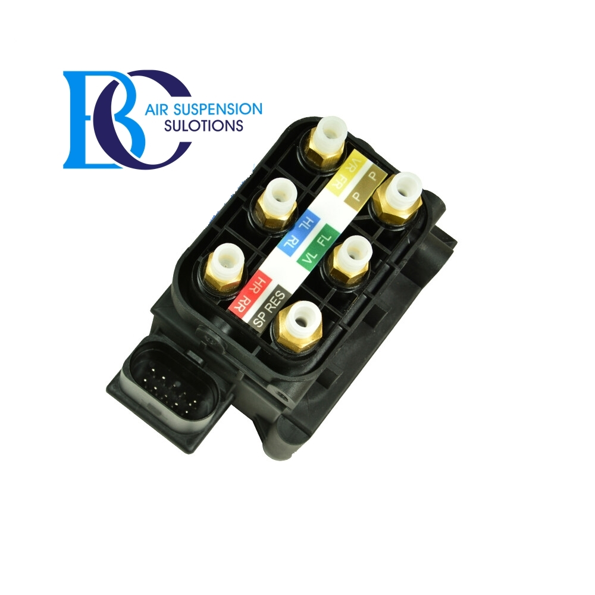

Description

This control valve (A0993200258) for the Mercedes GLC-Class X253, C253.

**Can be installed in the following vehicles:**

Mercedes-Benz GLC Coupé (C253) 2016--

Mercedes-Benz GLC (X253) 2015--

**OEM part number:**

0993200258, A0993200258